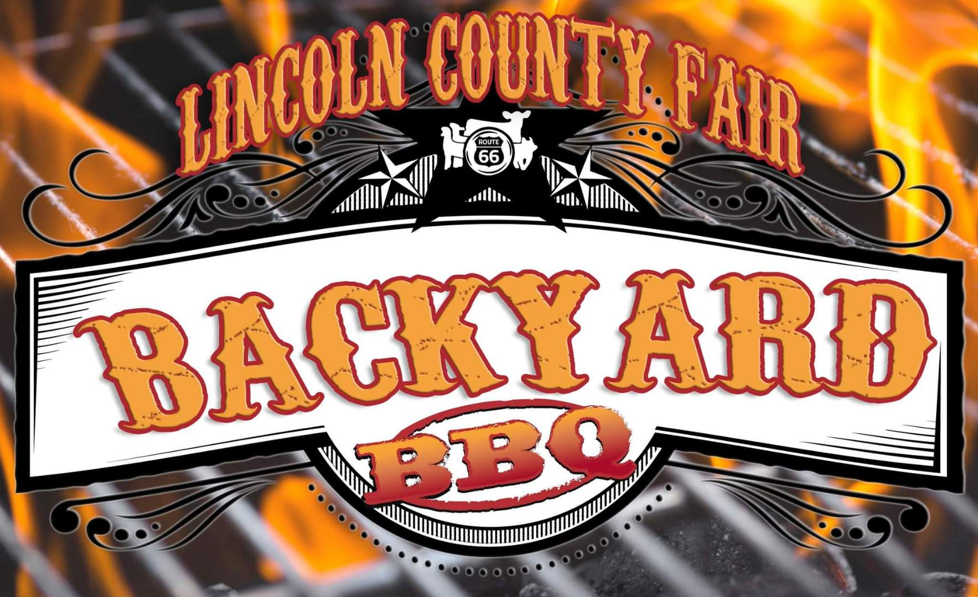
Cook-Off
Set-Up: Saturday, August 22nd starting 7 am
Cook-off and Judging: Saturday, August 22, 7 am – 4 pm

Bean’s Competition – (BBQ / Smoked / Homestyle, ect..)
Turn in time 1:30

Dessert Competition – (50% has to be made on site)
Turn in time at 2:15

Rib Competition – (Sparerib, St. Louise Style, Baby Back Ribs) Time to be turn in at 3:00

Awards: Top 5 overall Beans, Top 5 overall Dessert, Top 5 Ribs, Top 5 Overall with a combination of scores with beans, dessert and ribs.

For more information call Kellie Warne (405)258-3502 or email
kwarne@lincolncountyfairok.com
*Contestants must be backyard BBQ enthusiast!

